**Change Requirement of KPK**

**(External User and Administration)**

FRONT END APPLICATION

**User Control/Administration**

1. **Administration > User Administration > User Group**

Sample data:

Administrator will create 1 new user group: **PORT USER**

1. **Administration > User Administration > User Roles**

Sample data:

1. Shipping Agent

This role can access control menu list:

-Home

- Vessel

-Service Request

- Berth Planning

1. Forwarding Agent
2. Transporter

Tenant This role can access control menu list:

Home, Service Request, Berth Planning

1. Owner Cargo
2. Shipper
3. Others
4. **Administration > User Administration > User**

Sample data for User Shipping Agent:

1. Xing her Shipping
2. RNF Services

Sample data for Forwarding Agent:

1. ABAH AGENCIES (M) SDN BHD
2. GAPIMA SDN BHD
3. **User control access:**

Request create blocked checkbox in User form. If ( √) external user unable to login and an error will display ‘Your account has been blocked. Please contact finance department’.

**MENU LIST (External User)**

1. **HOME**
   1. Dashboard
   2. Change password
2. **Vessel**
   1. New Vessel Registration
   2. Notice of Arrival (NOA)
      1. New Notice of Arrival (NOA)
   3. View List of NOA
3. **Service Requisition**
   1. Service Request
   2. Service Request List

3.3 Permit Request

* + Diving Permit
  + Hot Work Permit
  + Radiography Permit
  + Bunkering/Loading Diesel Permit
  + Permit to Work (PTW)
  + Permit Confine Space
  + Pass Daily and Monthly

1. **Berth Planning**
   1. Berth View
   2. Berth Planning

**External User Screen**

**1. HOME**

* 1. **Dashboard**

KIV

Propose new display screen

* 1. **Change Password**

**-** Same like page admin

**2. VESSEL**

* 1. New Vessel Registration
* Need to create new form for this vessel registration.
* Field should have:

1. IMO Number
2. Vessel Name
3. Vessel Owner
4. Country/Flag
5. Vessel Draft (meter)
6. LOA
7. NRT
8. DWT
9. Shipping Agent (Auto get from login acc)

Tug for Barge

If ( √) for Tug for Barge. Create a form. Field should have

1. IMO Number
2. Tug Name
3. Tug Owner
4. Country/Flag
5. Draft
6. LOA
7. NRT
8. DWT
9. Shipping Agent (Auto get from login acc)

* System Process Flow:

External User

User register vessel View Details Submit - Notify by email to Admin

* 1. New Notice of Arrival (NOA)
* Header for screen NOA

Visit Details │ Operation Particular │ Upload Mandatory File │ Upload Additional File

* Type of activity

Radio Button for

CARGO

NON CARGO – Disable Operation Particular

* Tick box for Pilot Exemption
* Create new Notice of Arrival (NOA) form. (Visit Details)

Field should have:

* + 1. IMO Number
  1. -Dropdown list – Data get IMO from Vessel Master
  2. -When user select IMO Number details of vessel will auto display from Vessel Master (Vessel Name, Vessel Owner, etc

External User need to fill in **additional** field:

1. Vessel Type ( Dropdown list)
2. ETA
3. ETD
4. Terminal ( Dropdown list)
5. Arrival Draft
6. Departure Draft
7. Last Port
8. Next Port
9. Type of voyage

* For Pilot Exemption Vessel:

1. Master Name
2. Validity Date
3. Expiry Date

* Operation Particular

Field should have

1. Cargo type ( Dropdown list)
2. Cargo Name ( Dropdown list)
3. Tonnage
4. Operation ( Dropdown list)
5. Country of Origin ( Dropdown list)
6. Consignee/Consignor ( Dropdown list)

Option Others

Fill in details.

* Upload Mandatory File

1. Letter of Indemnity (Auto generate)
2. Second Schedule (Auto generate)
3. GTC (Auto generate)
4. DG
5. ISPS
6. ISSC
7. Crew List

*Auto Generate

* Update ETA
* Enable this tab when administrator approve and key in SCN Number.
* Open to edit until administrator key in ATA.
* Upload Additional File
* External user can upload it after Administrator approve and input SCN
  + 1. Stowage Plan
    2. JK55 & Customs Declaration Form
    3. Invoice and Packing List
    4. e-PENS
    5. e-DG

1. **Service Request**

3.1 Requisition Form

-Create new Requisition Form

-Field should have:

1. Customer ( Auto Login Acc)
2. Select location (Dropdown list as per existing )

**\*\*If user select PIER, compulsory to key in VESSEL NAME**

1. Add Services:

* Service Name (Dropdown List)
* Quantity
* Date Service Required
* Estimate usage hours

- Add button Estimation Cost generate after user submit request at View Service Request List

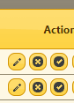

Use icon **trolley** for Estimation Cost button

* **Add condition external user not allowed to request less than 4 hours.**
  1. Request Permit

Create form for list of Permit:

1. Diving Permit

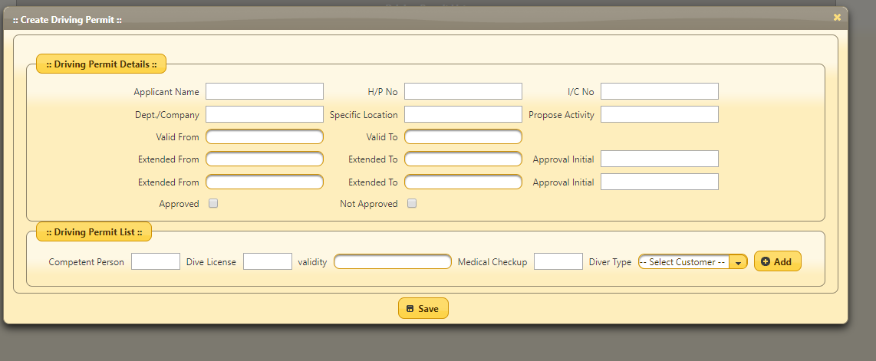

Purpose

Diving

1. Hot Work Permit
2. Radiography Permit
3. Diesel Permit

* Change to Bunkering Permit

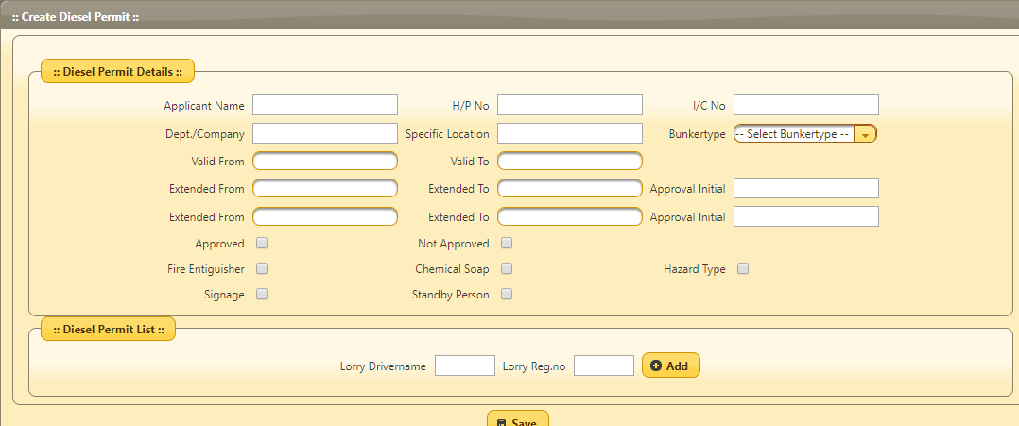

Bunkering Permit

1. Permit to Work(PTW)

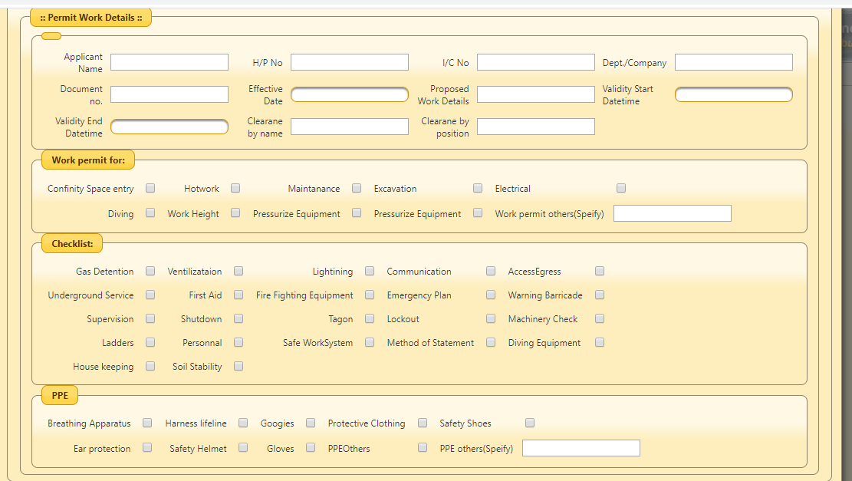

* Remove Document No. and Effective date in the form
* Spelling incorrect

a. Clearance by Name

b. Clearance by position

c. Working at height

d. Heavy Lifting

e. Access/Egress

f. Warning Sign / Barricade

g. Tag-on

h. Lock-out

i. Machinery

j. Save Work System

k. Harness & Lifeline

l. Goggle

j. Others(Please Specify)

**CLEARANCE (By Area Owner)**

I am satisfied with all safety precaution taken by the permit holder and hereby give clearance for this work to take place at the area of my control. All safety technical and operational factors had been taken into consideration and agreed between myself and the permit holder.

Restriction on work, kindly put in column as per sample given.

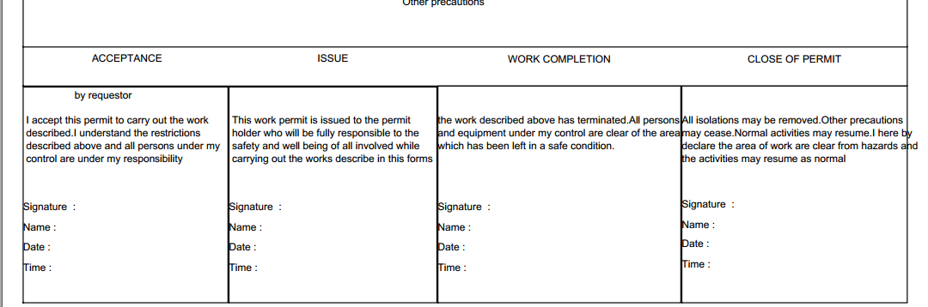

by (Konsortium Pelabuhan Kemaman)

1. Permit Confine Space

**Administrator Screen**

**1. HOME**

* 1. **Dashboard**

KIV

Propose new display screen

Vertical view

View by tab for each header

Request Privasia to propose the incoming NOA alert

* 1. **Change Password**

**-** Same existing

**2. PLANNING**

**1.1 Vessel Master**

* Incoming New Registration Vessel

Receive request Verify Data Request Administrator Approve Request

Notify user by email /Popup alert System Update data in Master Vessel

- After administrator approve, data will update in Master Vessel.

- Current practice in vessel master, need to input **vessel type** but now we decide **vessel type** grab from NOA.

**1.2 Vessel Visit List**

* Received new NOA
* Sorting List the request by date submitted.
* Type of status:

a. Pending – Receive new request

b. Approve – Administrator approve for 1st approval

c. Reject – Reject by Administrator

d. Confirm - Final approval

- Administrator verify data, review document, approve and **input the SCN Number.**

- All the data from NOA form will transfer to Vessel Visit List.

For Pilot Exemption Vessel:

1. Master Name
2. Validity Date
3. Expiry Date

and etc.

Header Each Vessel Visit Details

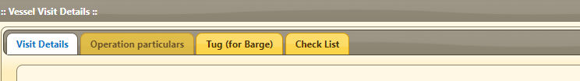

Change to Check List Mandatory Upload File from External User

* Add menu Check List Additional Upload File From External User

3. OPERATIONS

3.1 Service Request

Receive request Verify Data Request Administrator Approve Request

Notify user by email /Popup alert System Update data in Service Request

**4. Berth Planning**

* 1. Berth View

-Selecting Terminal and Date

-Propose to make it smaller for gap of scale Y axis. Make it AM and PM.

-Live Performance Update (TODAY)

-Sorting by ATB and ETD

- Icon of Vessel to differentiate color by loading or discharge activity (NOA)

* 1. Berth Planning

-Selecting Terminal and Date

-Propose to make it smaller for gap of scale Y axis. Make it AM and PM.

-Sorting by ETB and ETD

-Icon of Vessel to differentiate color by loading or discharge activity (NOA)

** If